Testing Steps for Dev Environment
10. My Work
1. My Work: In My Work we can we can execute the schedule we created in Process Schedule
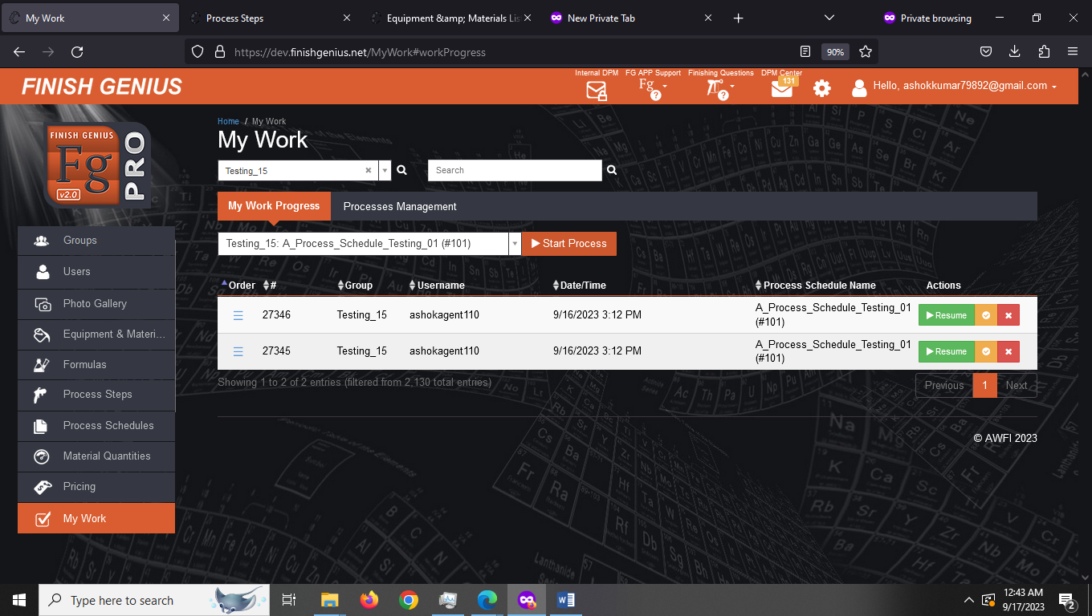
Step-1 Search the schedule you wish to execute and click on Start Process
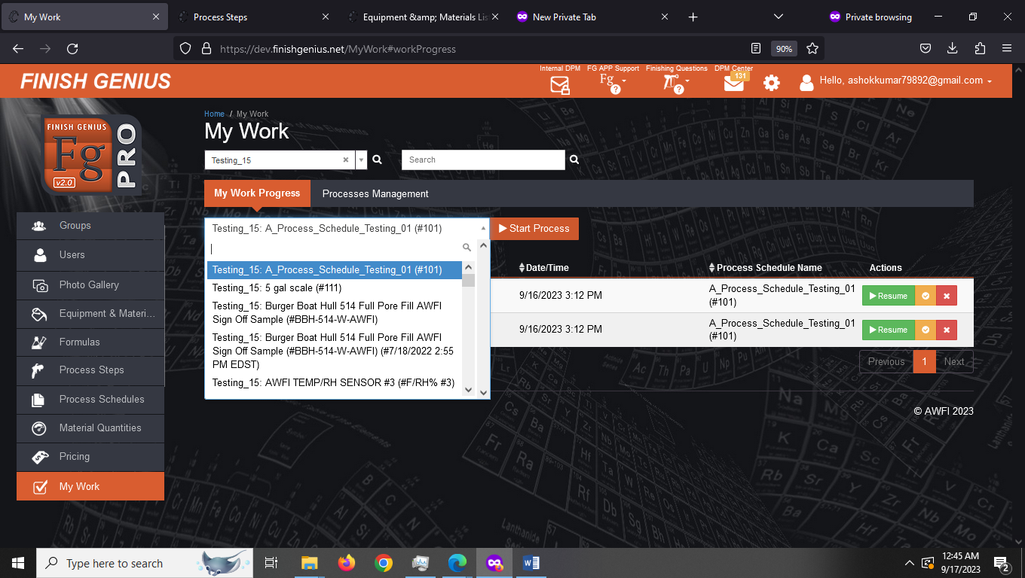
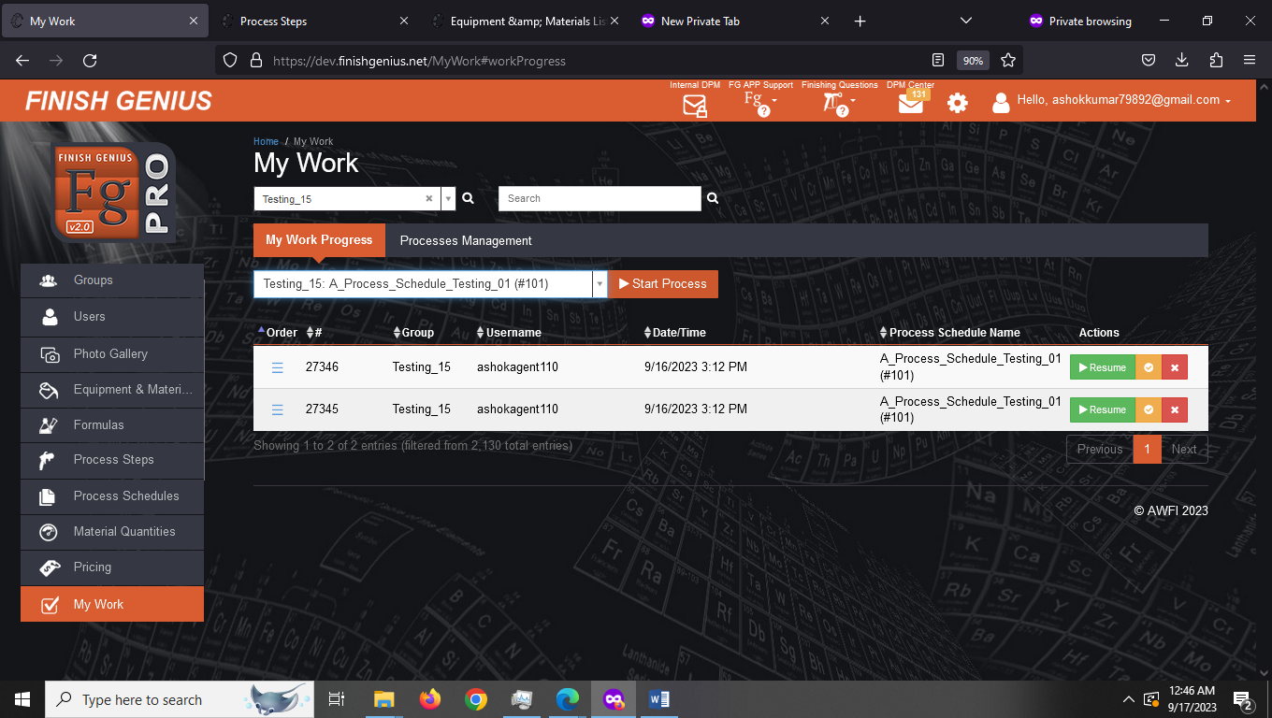
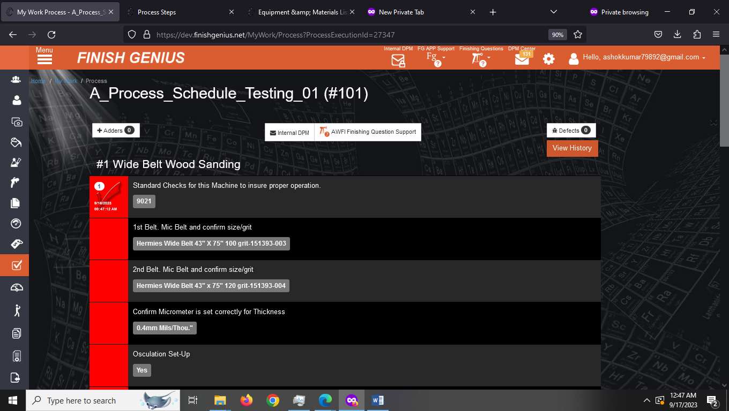

2. My Work Management You can click on Red Box on left hand side and it will automatically display date and time when you clicked it. In this way you can monitor and keep track of your process and also execute steps from My Work

Conclusion
1. We are able to execute newly created schedule

